HTCPSA AGM & Annual Dinner on Apr 27 2019 (Saturday)
Theme: Bling Bling
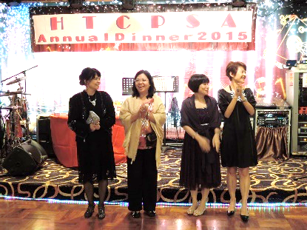
Lucky Dragon Restaurant 彩龍大酒樓
Wo Chai Street, Tai Hung Tung Road, Shek Kip Mei石硤尾大坑東道窩仔街

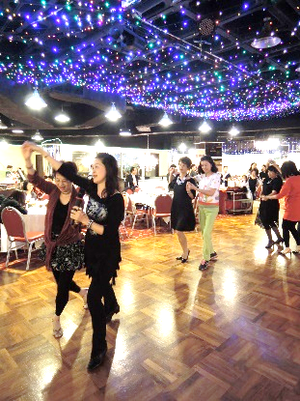
Tentative rundown:
6:30-7:30pm Dancing + Game
7:30pm HTCPSA AGM
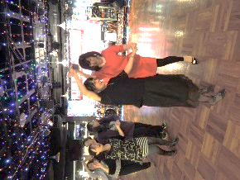
8:00pm Dinner + Lucky draw
+ The Most Bling Bling Competition
+ Children Talent Show

Ticket Price:
Adult @$380
Child/ Student/Over 65 @$300

Booking:
Tickets will be allocated on a first-come-first-serve basis. In order to avoid any disappointment, please book early by submitting the Order Form and cheque or bank-in slip as soon as possible.

2019 ANNUAL DINNER TICKET ORDER FORM
Deadline: 31 March, 2019
Name: (English) Email Address: @________________
Year of graduation: (F.5) _____ (F.6/7) _____ (If not applicable, Year of leaving HTC: _____)
Mobile/Whatsapp Number:
Contact Address:
No. of tables (Tables are sold in multiples of six only. )
No of participants:
- Adult: ____ x $380
- Student/ Child/ >65: ____ x $300
Sr Juliana Relief Fund Donation: $___________
Total: $ ___________
- 0.5 (6 seats)
- 1 (12 seats)
- 1.5 (18 seats)
- 2 (24 seats)
- 2.5 (30 seats)
- 3 (36 seats)
- 3.5 (42seats)
- 4 (48 seats)

Enclosed please find my
cheque (Bank: ____________________ No: _____________ )
Crossed Cheques, made payable to “HOLY TRINITY COLLEGE PAST STUDENTS’ ASSOCIATION”, together with this form by post to HTCPSA, No.3, Wai Chi Street, Shek Kip Mei, Kowloon.

Bank-in slip
Bank Name: Hang Seng Bank
A/C NO.: 287-4-127547 A/C Name: Holy Trinity College Past Students’ Association
Please email the bank-in slip together with the form to Daisy at contact@htcpsa.org.hk

I can donate presents/gifts for lucky draw at the dinner. Please contact me directly.

Further information can be obtained from Daisy Yew at 9255 7048 (by Whatsapp) or e-mail to contact@htcpsa.org.hk.

